MACHINE LEARNING LAB
CYCLE 4

1.Using the iris data set implement the KNN algorithm. Take different values for Test and training
data set .Also use different values for k. Also find the accuracy level.

CODE

import numpy as np
import matplotlib.pyplot as plt
import pandas as pd
from sklearn.model_selection import train_test_split
from sklearn.neighbors import KNeighborsClassifier

from sklearn.metrics import accuracy_score

dataset = pd.read_csv("iris.csv")
X = dataset.iloc[:, :-1].values
y = dataset.iloc[:, 4].values

X_train, X_test, y_train, y_test = train_test_split(X, y, test_size=0.20)

classifier = KNeighborsClassifier(n_neighbors=50)
classifier.fit(X_train, y_train)
y_pred = classifier.predict(X_test)

accuracy = accuracy_score(y_test,y_pred)
print("Accuracy :",accuracy)

for(i,j) in zip(y_pred,y_test):
if i != j:
print("actual value:",i,"\npredicted value :",j)
print("Number of mislabeled points from test data set :",(y_test != y_pred).sum())

OUTPUT
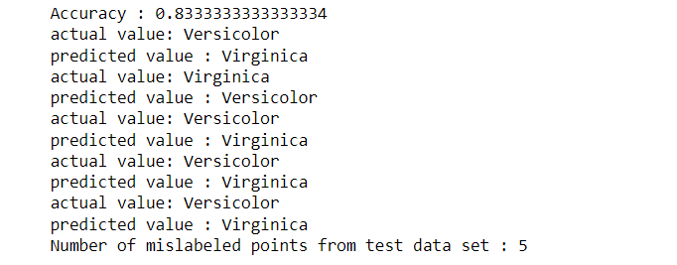

2.Download another data set suitable for the KNN and implement the KNN algorithm. Take different
values for Test and training data set .Also use different values for k.

CODE

import numpy as np
import matplotlib.pyplot as plt
import pandas as pd
dataset = pd.read_csv("breastcancer.csv")
# dataset.head()
# dataset.info()
x = dataset.iloc[:, :-1].values
print(x)
y = dataset.iloc[:, 4].values
print(y)
from sklearn.model_selection import train_test_split
X_train, X_test, y_train, y_test = train_test_split(x, y, test_size=0.20)
from sklearn.neighbors import KNeighborsClassifier
classifier = KNeighborsClassifier(n_neighbors=5)
classifier.fit(X_train, y_train)
y_pred = classifier.predict(X_test)
from sklearn.metrics import classification_report, confusion_matrix
# print(classification_report(y_test, y_pred))
from sklearn.metrics import accuracy_score
print ("Accuracy : ", accuracy_score(y_test, y_pred))
# df = pd.DataFrame({'Real Values':y_test, 'Predicted Values':y_pred})
# df
for(i,j) in zip(y_pred,y_test):
if i != j:
print("actual value:",i,"\npredicted value :",j)
print("Number of mislabeled points from test data set :",(y_test != y_pred).sum())

OUTPUT
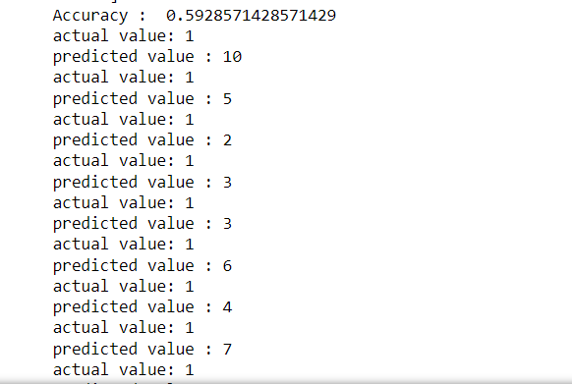

3.

i)CODE(GAUSSIAN)

import numpy as np
import matplotlib.pyplot as plt
import pandas as pd
dataset = pd.read_csv('iris.csv')
X = dataset.iloc[:,:4].values
y = dataset['variety'].values
dataset.head(5)
from sklearn.model_selection import train_test_split
X_train, X_test, y_train, y_test = train_test_split(X, y, test_size = 0.2)
from sklearn.naive_bayes import GaussianNB
classifier = GaussianNB()
classifier.fit(X_train, y_train)
y_pred = classifier.predict(X_test)
y_pred
from sklearn.metrics import confusion_matrix
cm = confusion_matrix(y_test, y_pred)
from sklearn.metrics import accuracy_score
print ("Accuracy : ", accuracy_score(y_test, y_pred))
cm
for(i,j) in zip(y_pred,y_test):
if i != j:
print("actual value:",i,"\npredicted value :",j)
print("Number of mislabeled points from test data set :",(y_test != y_pred).sum())

OUTPUT
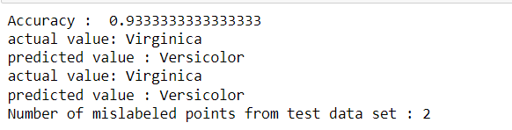

ii)CODE(Bernoulli)

import numpy as np
import matplotlib.pyplot as plt
import pandas as pd
dataset = pd.read_csv('iris.csv')
X = dataset.iloc[:,:4].values
y = dataset['variety'].values
dataset.head(5)
from sklearn.model_selection import train_test_split
X_train, X_test, y_train, y_test = train_test_split(X, y, test_size = 0.2)
from sklearn.naive_bayes import BernoulliNB
classifier = BernoulliNB()
classifier.fit(X_train, y_train)
y_pred = classifier.predict(X_test)
y_pred
#from sklearn.metrics import confusion_matrix
#cm = confusion_matrix(y_test, y_pred)
from sklearn.metrics import accuracy_score
print ("Accuracy : ", accuracy_score(y_test, y_pred))
for(i,j) in zip(y_pred,y_test):
if i != j:
print("actual value:",i,"\npredicted value :",j)
print("Number of mislabeled points from test data set :",(y_test != y_pred).sum())

OUTPUT
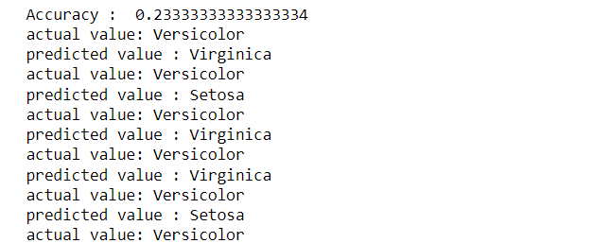

4.

